USERS’ MANUAL

INTRODUCTION

The users’ manual contains information for the user to make full use of the system. It also gives him the familiarity of the navigation flow. This serves as the guide to the user. This manual has a description of the system functions and capabilities, contingencies and step-by-step procedures for the application to use. The manual also includes the installation procedures, product functionalities, mechanics and rules. The purpose of this manual is to provide the player with a comprehensive guide for understanding and utilizing the application. User manual aims to give precise instructions for the player to have a clear view about the application. Before installing Aqua Hero, make sure that your smartphones or android devices meet the following software and hardware requirements. It is needed to run the application successfully.

INSTALLATION PROCEDURES

1. Double click the installer of the game found in your device files or where specific directory it is saved shown in Screenshot 1.

.

Screenshot 1. APK Directory.



2. After tapping the installer, it asks confirmation either to install or to cancel the process shown in Screenshot 2.

Screenshot 2. Installer Confirmation.

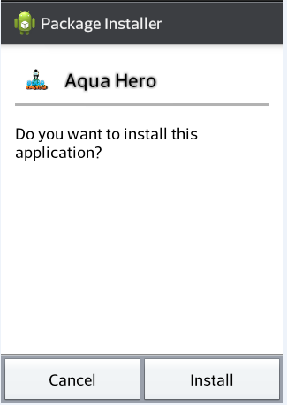

3. After tapping the install button, wait until loading process is done as shown in Screenshot 3.

Screenshot 3. Installation Process.

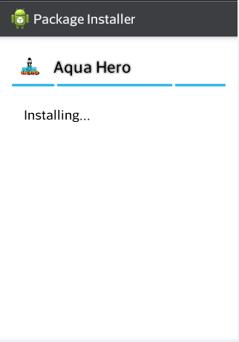

4. After the installation process is done, the application is now ready to use. Tap either to open the game or tap done to go back to the homepage shown in Screenshot 4.

Screenshot 4. Done Installation.

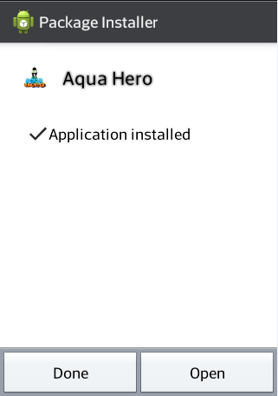

5. The application is now ready for use and is available in the device application shown in Screenshot 5.

Screenshot 5. Application Availability.

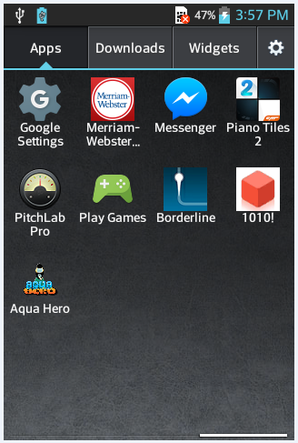

APPLICATION FUNCTIONALITIES

The user must successfully install the application to enjoy playing the game. This section elaborates the functionalities of the Aqua Hero. Different interface in the game is also discussed for user’s guidance.

1. Scoring scheme

This section shows the different corresponding score of each wastes, chemicals, items, and power-ups in the game. The scoring scheme of waste is based on the three guidelines; minimal is 10 points, moderate is 15 points, and severe got the highest score of 25. Power-ups also help the player to increase the score in each level.

B. Storyline Interface

The storyline interface is the first interface right after the loading screen is done. The character and the enemy have a short conversation before each stages start and after the stage is done. After the short conversation is done, the application automatically proceeds to the main menu. The storyline interface is shown in Screenshot 6.

Screenshot 6. Storyline.

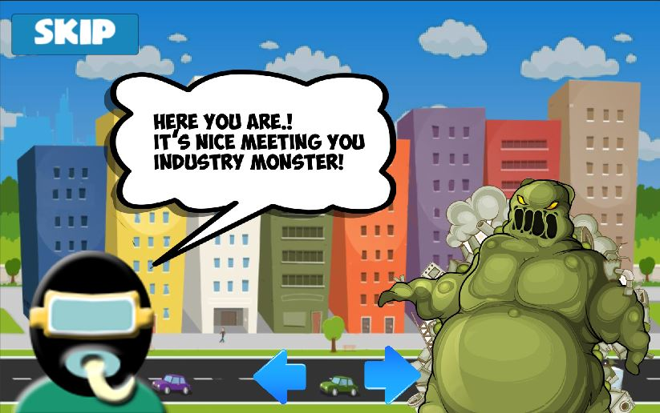

C. Game Main Menu Layout

The main menu layout shows and describes every module that can be found in the game. There are five buttons in the main menu: settings, facts, shop, high score, and help. The letters below show the different labels of the buttons in the main menu that is shown in Screenshot 7.

F

C

Screenshot 7. Game Menu.

A

B

G

D

E

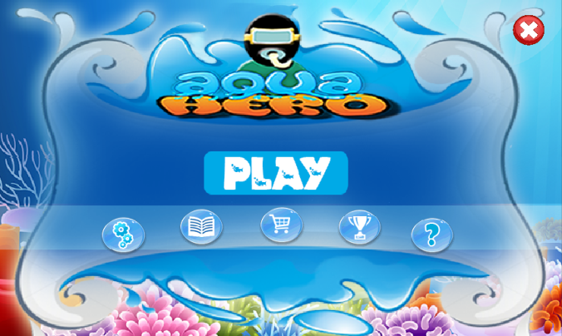

A. It is the game setting button wherein the player can adjust the music as well as the background music.

B. It is the facts button wherein the player can learn about waste facts, waste effects, and historical events regarding water pollution.

C. It is the shop button wherein the player can buy items and power-ups.

D. It is the high score button wherein the player can monitor the score and the name that got the highest score in each level.

E. It is the help button wherein the player can choose among two buttons; the tutorial button to help the player understand the game mechanics as well as the information of the developer and the brief description of the game inside the developer button.

F. It is the play button wherein the player can now proceed to the game play and start the first stage.

G. It is the exit button wherein the player has the option either to stay or to leave the game.

D. Levels and Stages Interface

The levels and stages show both lock and unlock feature of the game. The player must complete current level in order to proceed to the next levels and unlock the next stage. There are four stages in the game: residential, agricultural, mining, and industrial. Each stage is composed of three levels. Stages and levels are shown in Screenshot 8.

A

Screenshot 8. Game Levels and Stages.

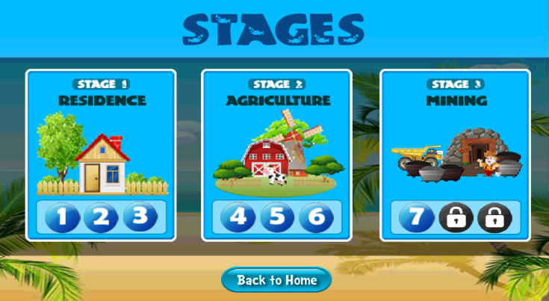

B

1. This button represents level under stages.
2. This button leads the user to the main menu.

E. Game Layout

The game layout is the official start of the game. It consists of different icons above and that is essential to the side of the player and shows the functionality of the game. The illustration of the game layout is shown in Screenshot 9.

Screenshot 9. Game Layout.

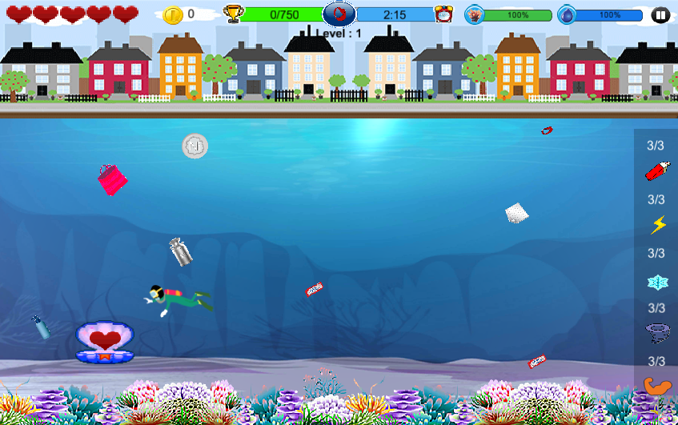

A

B

C

D

E

F

G

H

I

J

A. The heart is the life of the player and must be maintained by avoiding the monster fish.

B. The coin is the total coins that the player gains in playing the game.

C. The trophy is where the total goal scores of the player that must reach in order to pass the level.

D. The circle in the upper middle helps the player know the next waste to be thrown in the water.

E. The time show the given time for the player to complete the level.

F. The coral show the percentage of how much the coral is destroyed.

G. The water shows the percentage of how much the water is polluted.

H. The pause shows different options for the player to resume the game, restart the game, back to stages, and to adjust music settings.

I. The pearl has heart inside and character can get it every ten seconds and it adds to the player’s life which is the heart.

J. This is the player’s power-up inventory that shows the different available

power-ups based on the number.

F. Settings Interface

Settings interface shows the two options for the player to adjust the volume of the music background and the sound. This option gives the player ease of comfort while playing the game. The player must slide the bar forward or backward to adjust the volume of the sound. The setting is shown in Screenshot 10.

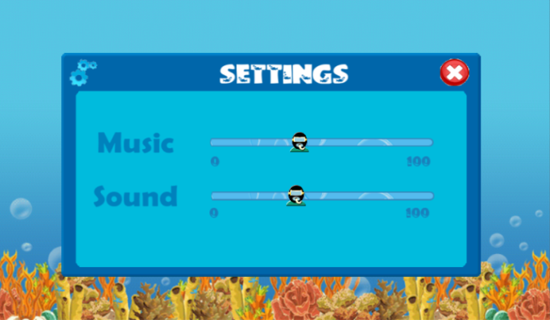

Screenshot 10. Game Settings.

B

A

1. This sliding bar is used to adjust the volume.
2. Exit button allows the player can go back to the main menu.

G. High Score Interface

High score interface shows the score record of the player in each level. The highest score in each level got the chance to put the score in the high score interface. The player must reach the highest score to have the chance to be part of the high scorer lists. The game high score is shown in Screenshot 11.

Screenshot 11. Game High Score.

A

B

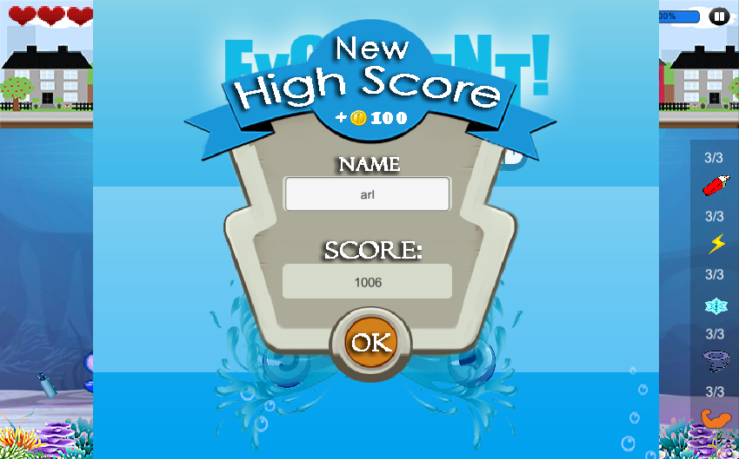

1. Input player’s name as a high scorer in each level.
2. Tap Ok button when done writing name.

H. Waste Facts Interface

Waste fact interface shows the different educational modules in the game. There are three buttons in the waste facts interface: waste facts, waste effects, and historical events. Aqua Hero is not only for entertainment but it is also educational that can improve player’s environmental awareness. The game facts is shown in Screenshot 12.

Screenshot 12. Game Facts.

D

C

B

A

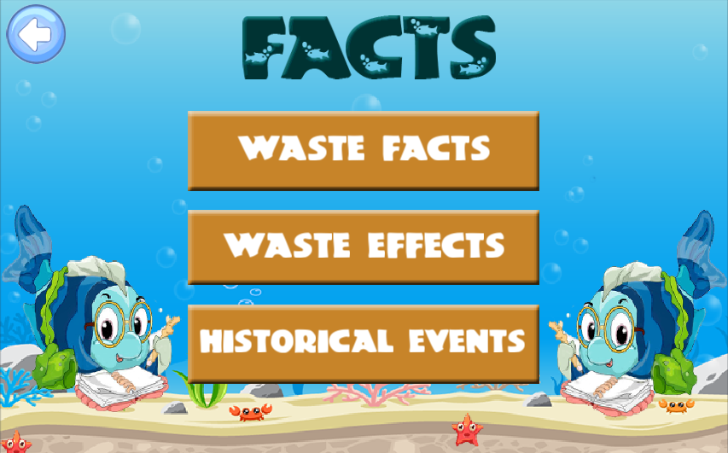

1. This button leads the player to the main menu.
2. This button leads the player to the different waste facts.
3. This button leads the player to the different waste effects.
4. This button leads the player to the historical events from previous years until 2015.

I. Help Interface

Help interface guides the player how to properly play the game. It includes tutorial and credits. The tutorial is where the player learns how to play the game by following the instructions given by the character. The player can skip the tutorial if he wishes too. Also, the credit is where the brief description of the game is shown as well as the information of the developers. The game help is shown in Screenshot 13.

Screenshot 13. Game Help.

A

C

B

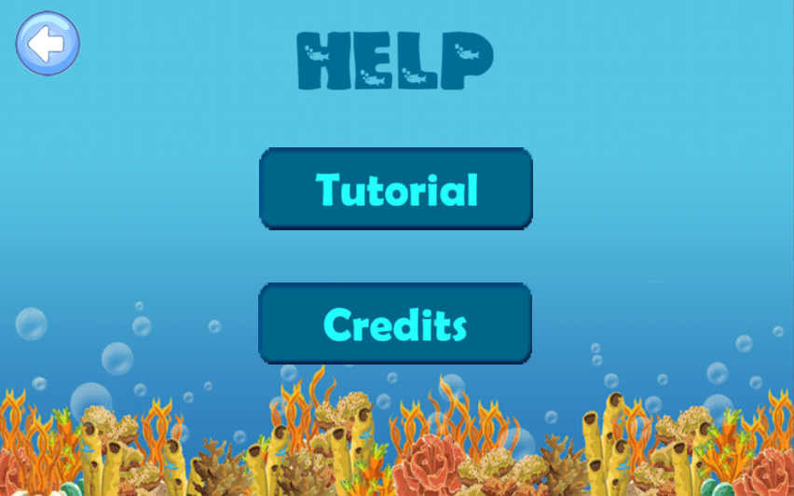

1. This button leads the player to undergo tutorial before playing the game. It helps player understand the game well.
2. This button leads the player to know brief information about the developer and the brief description of the game.
3. This button leads the player back to the main menu.

J. Shop Interface

Shop is essential in playing the game. Shop has two modules, the item and power-ups. The item module consists of three items: net, diving suit, and bag. Also, the power-up module consists of six items. The game shop is shown in Screenshot 14.

A

B

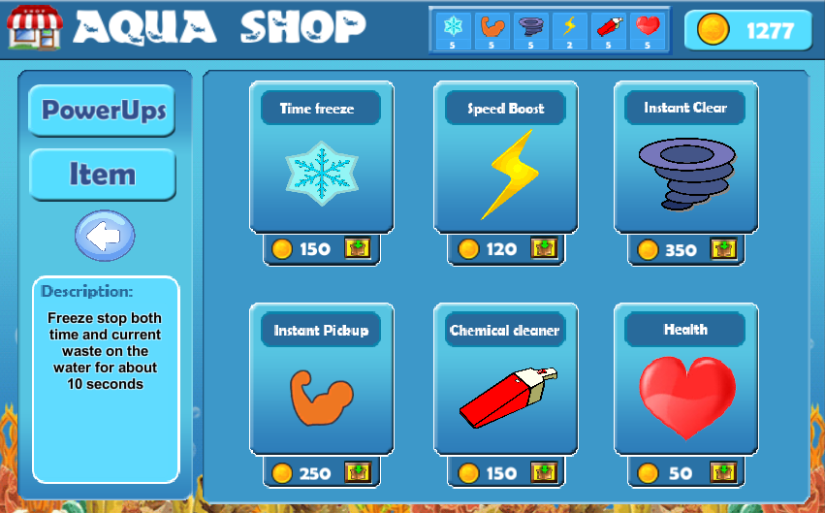

C

D

E

Screenshot 14. Game Shop.

1. This is the current total coins of the player.
2. This is the current inventory of the player’s power-ups.
3. This is power-up button that shows six different power-ups.
4. This is item button that shows three items.
5. This button leads the player to the main menu.